Learning Rate: 0.05

Iterations: 291

Final Formula: y = 0.3695118\*x + 3.13222

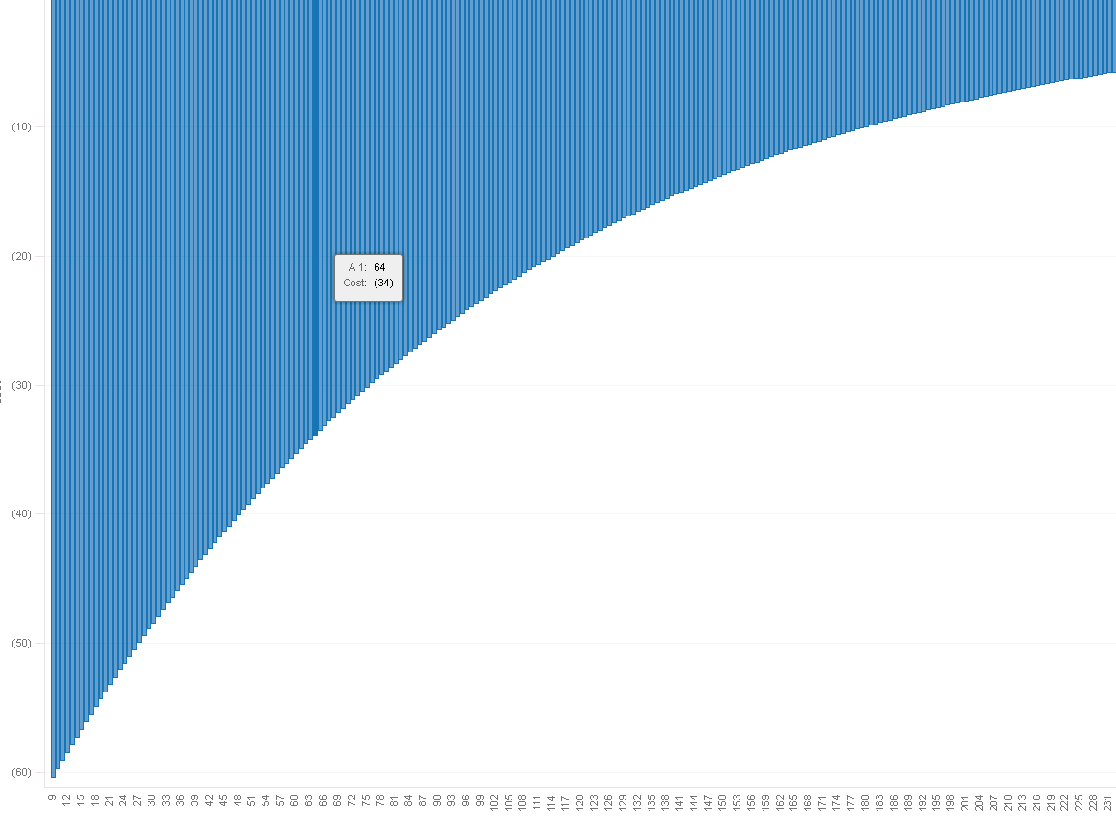

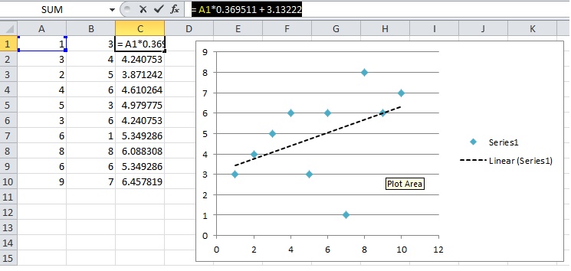

Learning Rate: 0.08

Cannot convergence

